Relevant Project Experience & System Establishment Capabilities

- Modulus C & D – Project DMS & Safety DMS:
DMS (Document Management System)

Project reference: Centralized Project Information Management System for SFK (2025), DMS for WAGAS Group (2026) etc.
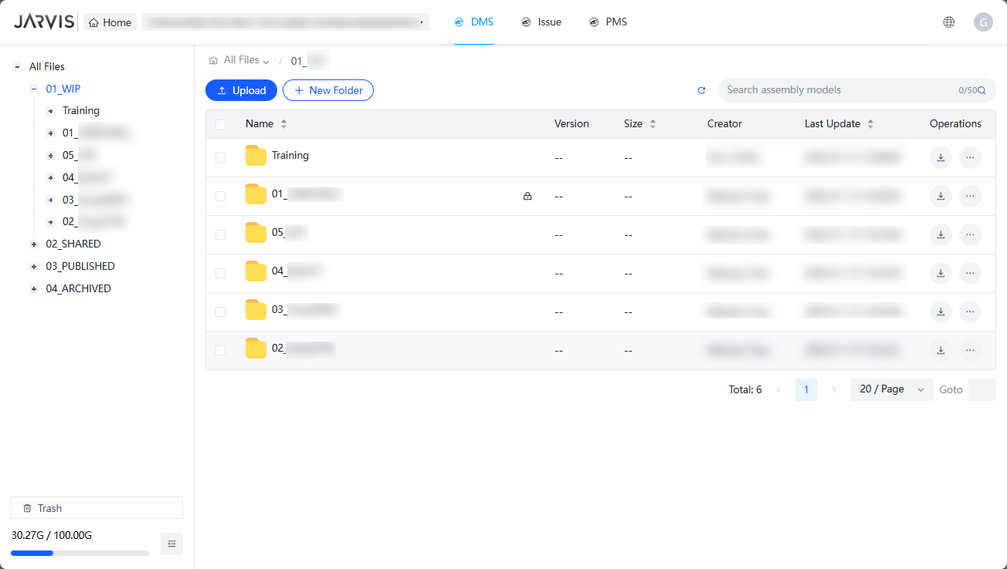

- Modulus E – Safety Modulus including e-forms and 4S:
E-permit System
The system covers a comprehensive range of permits, including Hot Work, Working at Height, and Confined Space permits. Key features include electronic signatures, auto-expiration of permits, and automated approval workflows. This module serves as an integral component of 4s.

Project reference: CV202304 for CCECC (H.K.) Limited (2024), GE202422 for Tysan (2025), Project of CU Area 39 for Penta Ocean (2025), etc.

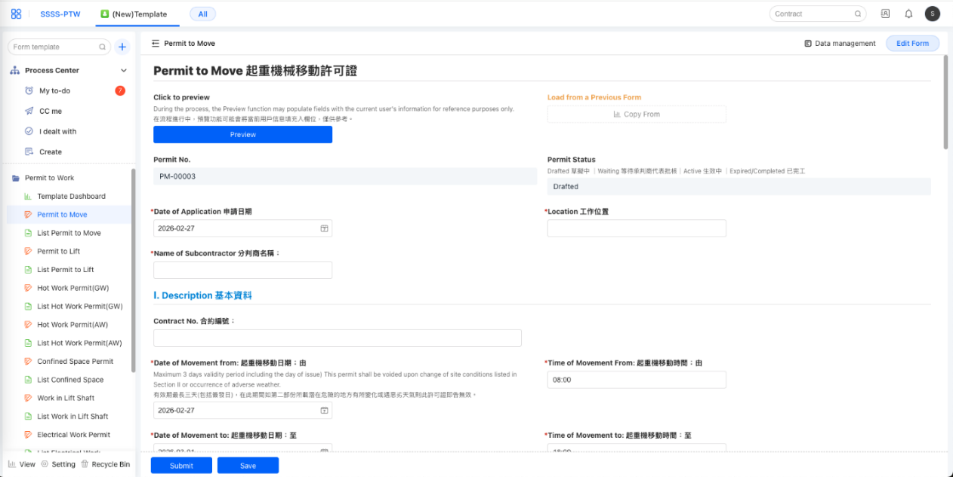
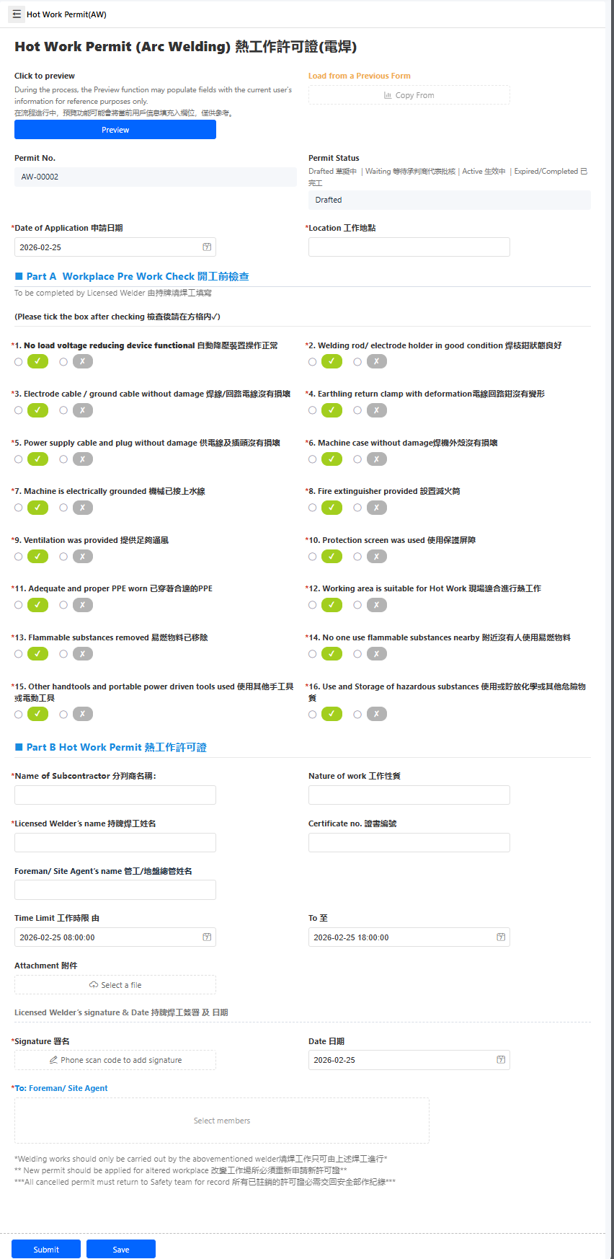
- Modulus F & G – Quality & Environmental modulus including e-forms:
DWSS (Digital Works Supervision System) - Example from iSuper 2.0 for New Extension Railway Projects
A comprehensive Construction Project Management System featuring customized multi-stage workflows for critical forms such as RICS, Site Observation, and NCR, alongside seamless API integrations with the Material Testing System and ACC BIM Platform. Powered by iSuper 2.0, the solution includes a customized dashboard for automated data analysis, which has demonstrably enhanced project traceability and delivered valuable strategic insights.
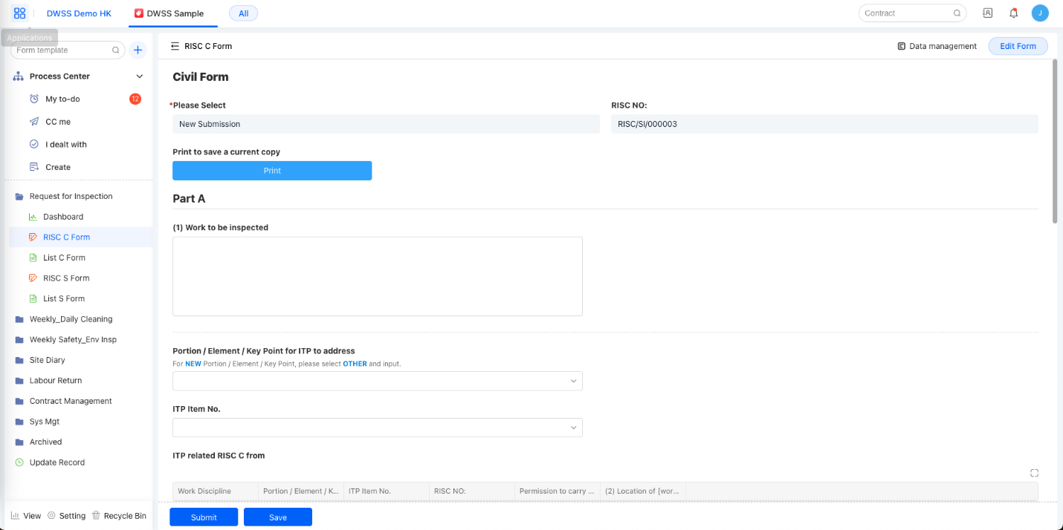
Request for Inspection Form (for Quality Check) - Dashboard
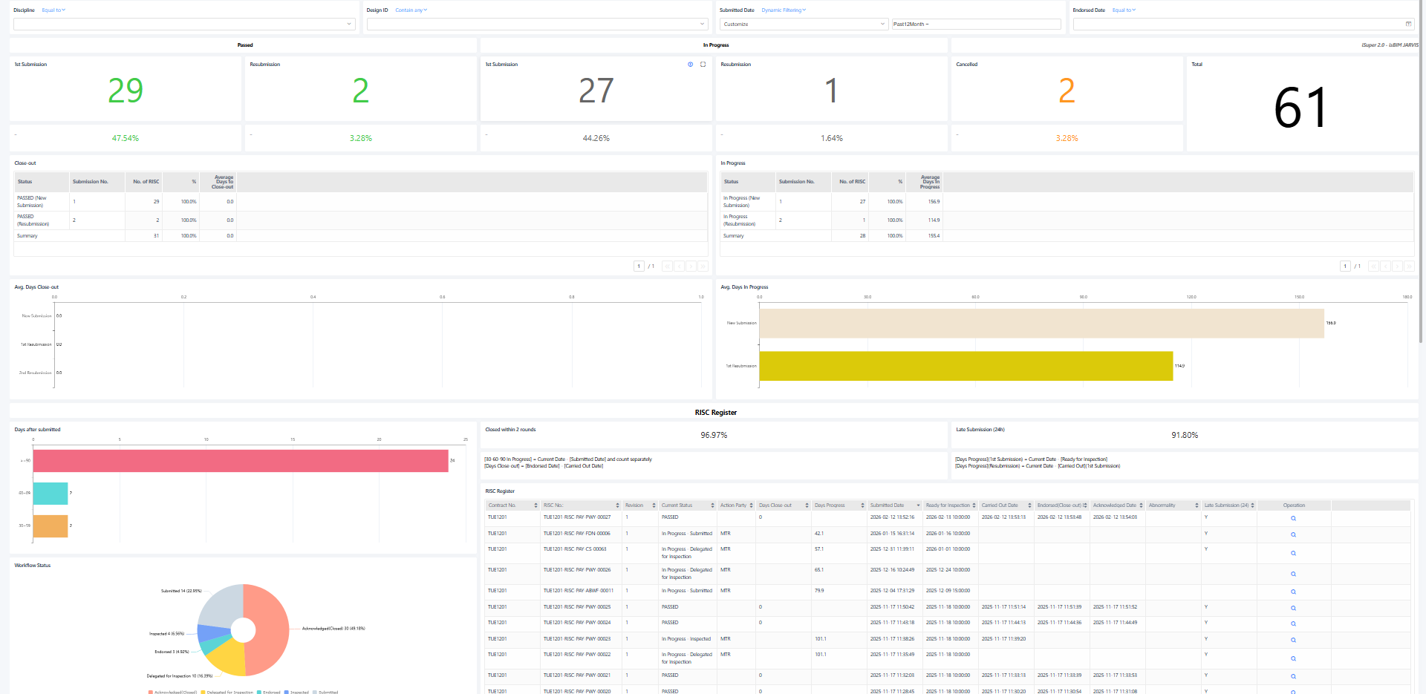
Request for Inspection Form

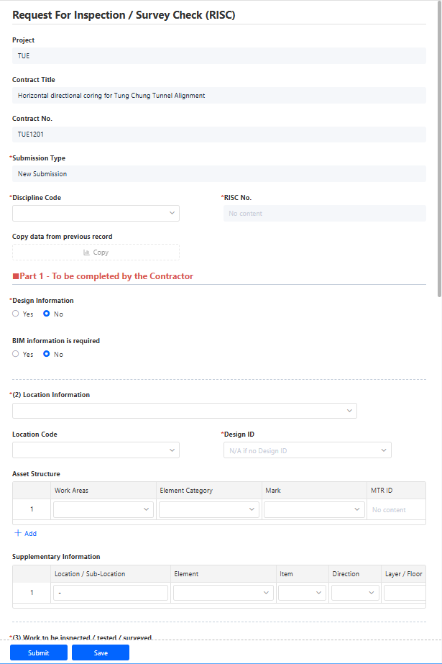
Site Supervision Plan Forms - Dashboard
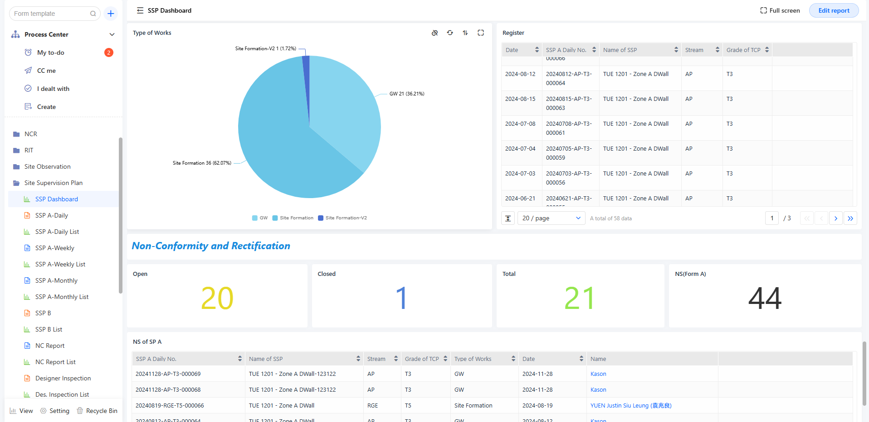
Site Supervisor Plan Forms – SSP Form A Record of Specific Tasks Performed by TCP Stream
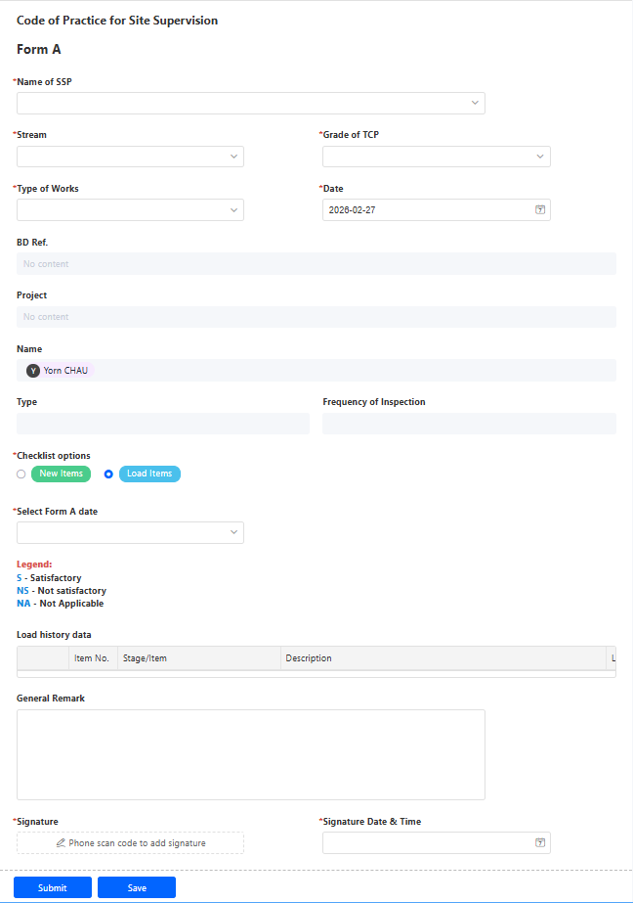
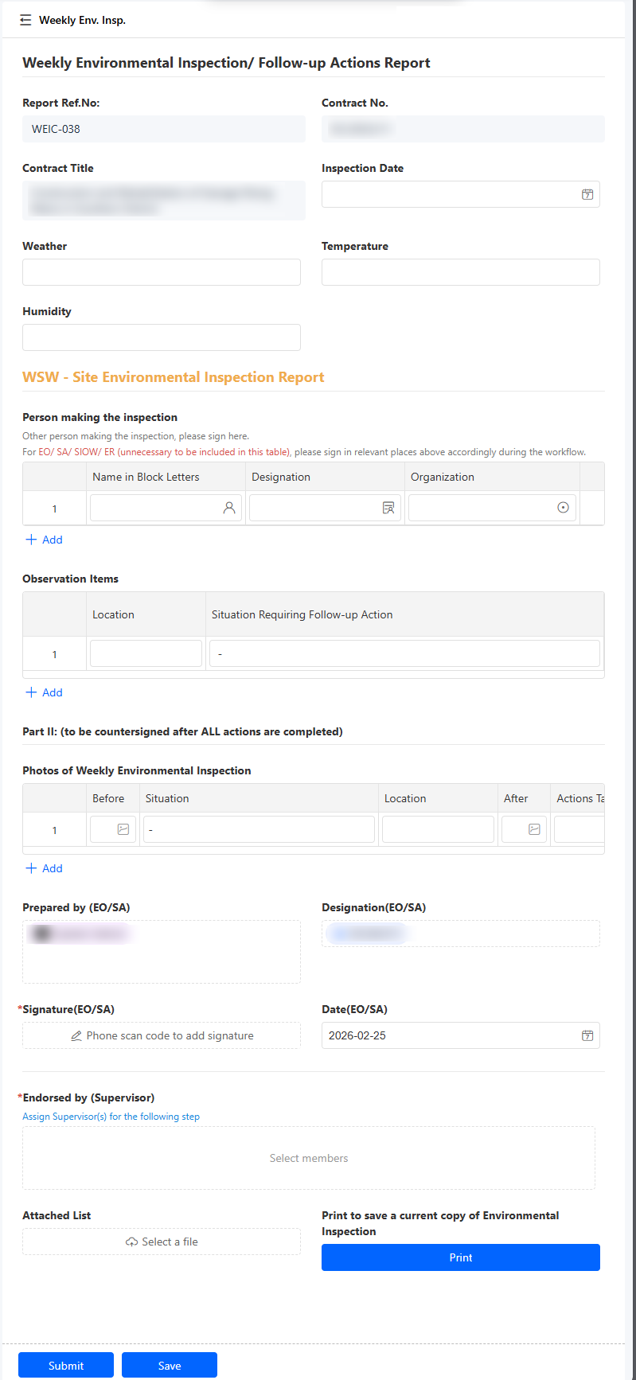
- Modulus H – QS Modulus:
JARVIS Pay
An AI-powered payment system that transforms traditional handwritten forms into automated digital workflows—capturing data via intelligent recognition, performing automatic calculations, and visualizing insights through dynamic reports.

Project reference: JARVIS Pay for CCECC (H.K.) Limited (2025), JARVSI Pay for Wecon (2025), JARVIS Pay for Woon Lee Construction Co Ltd (2025), etc.
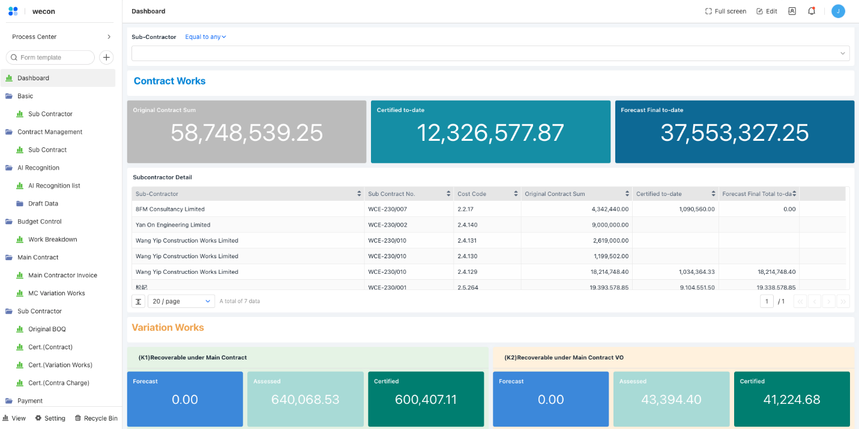
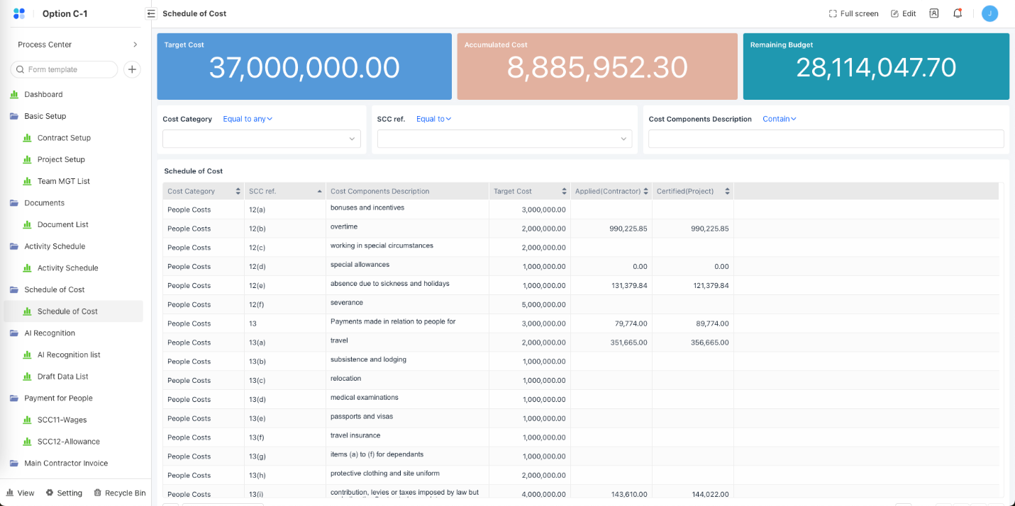
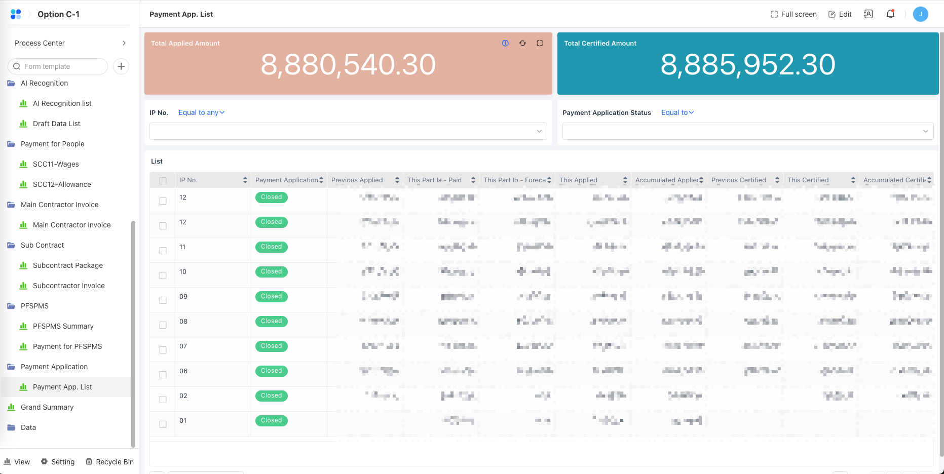

- Modulus I – Procurement Modulus:
Procurement and Inventory Management System (for internal use)
A bespoke solution specifically engineered for our 4S, which serves as a comprehensive platform that unifies the entire procurement lifecycle—from Purchase Requisition (PR) to Purchase Order (PO) and Payment Lists—while also managing the full asset lifecycle post-purchase, including inbound stocking, real-time inventory tracking, and outbound distribution.
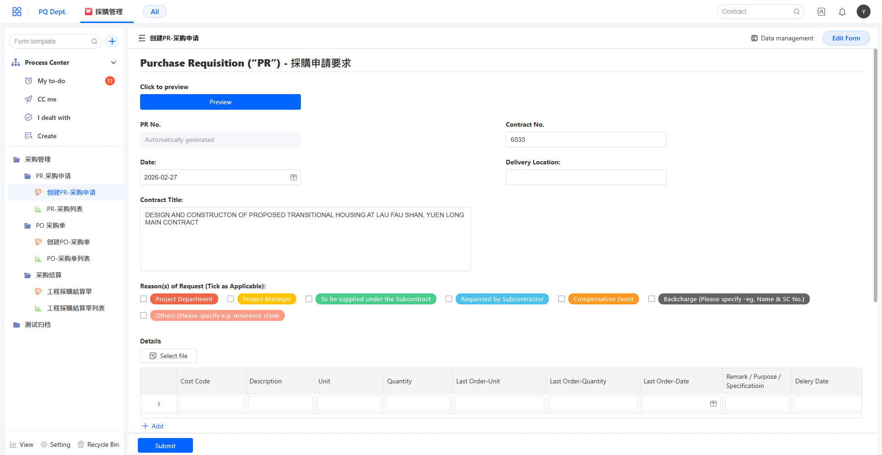
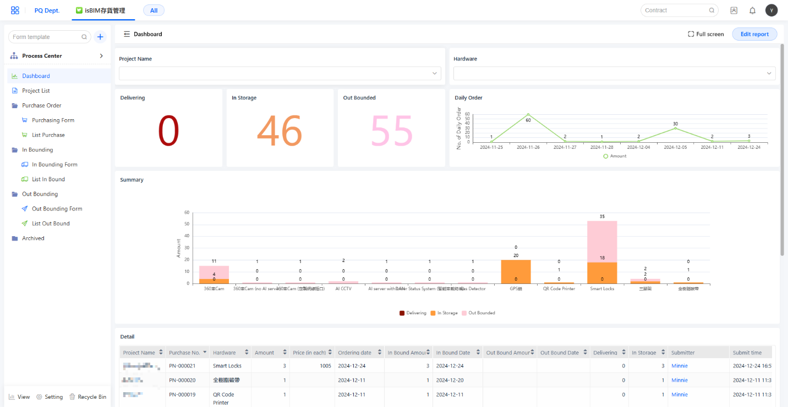

- Modulus J - Human Resources Modulus:
OA System (for internal use)
A solution designed to streamline workforce tracking, integrate leave management, overtime requests, and shift scheduling into a unified automated workflow.
